| Home Component 1 | Text field | Displays the title of the app |
| --- | --- | --- |
| Home Component 2 | Button | Starts a new game |
| Home Component 3 | Button | Goes to the Settings page |
| Home Component 4 | Button | Goes to the How To Play page |
| Settings Component 1 | Image | Image of settings logo |
| Settings component 2 | Image | Cobber Themed Image |
| Settings Component 3 | Logo | Logo that says settings |
| Settings component 4 | Button | Button to board themes |
| Settings Component 5 | Button | Button for Music/Sounds |
| Settings Component 6 | Button | Return to home button |
| How to Play Component 1 | Image | Potential Checkers Image |
| How to Play Component 2 | Image | Potential Checkers Image |
| How to Play Component 3 | Image | Potential Checkers Image |
| How to Play Component 4 | Image | Potential Checkers Image |
| How to Play Component 5 | Button | Returns to Home Menu |
| How to Play Component 6 | Text Field | “How to Play” Title |
| How to Play Component 7 | Text Field | Description of How to Play |
| GamePlay Component 1 | Button | Return to home |
| GamePlay Component 2 | Text field | Displays the title of the app |
| GamePlay Component 3 | Timer | Displays the timer |
| GamePlay Component 4 | Button Array | Game board |
| GamePlay Component 5 | ?? | Taken pieces go here |
| EndGame Component 1 | Text field | Displays the end game screen |
| EndGame Component 2 | Array? | Displays the statistics |
| EndGame Component 3 | Button | Return to home/ play again |

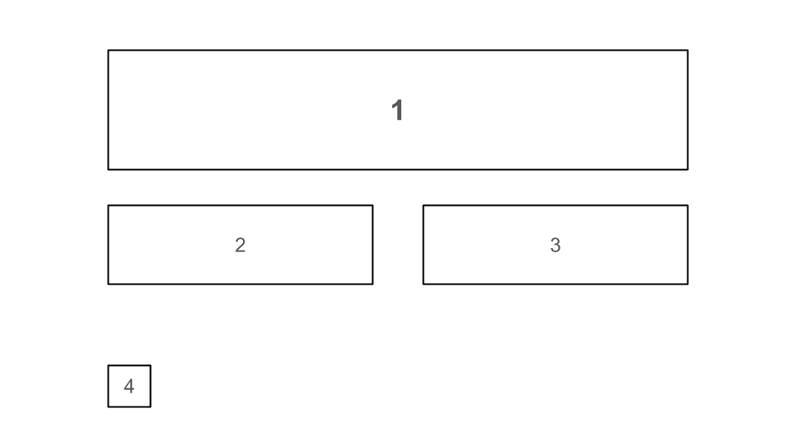

Screen 1: Home

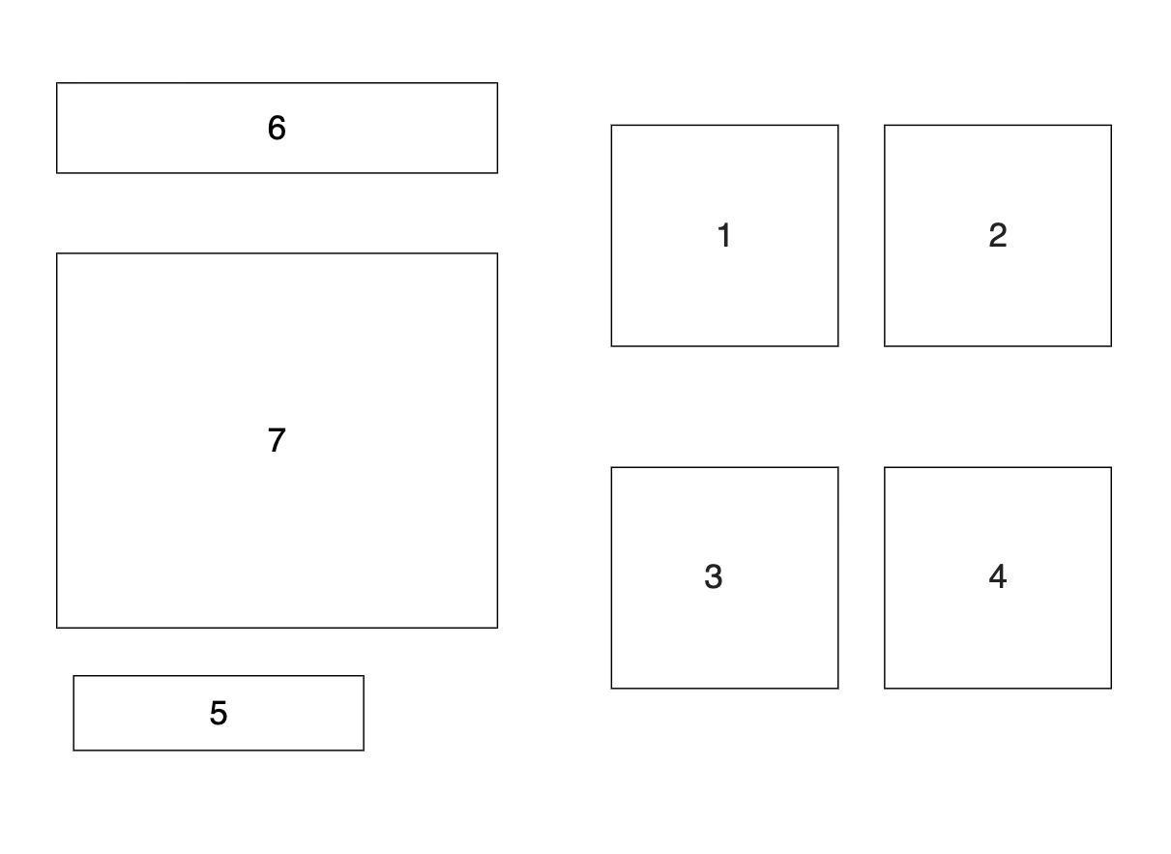

Screen 2: How to Play

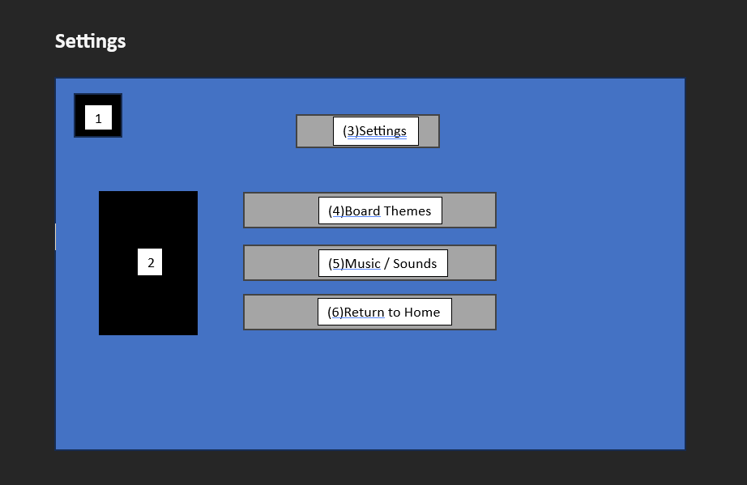

Screen 3: Settings

Screen 4: Game Play

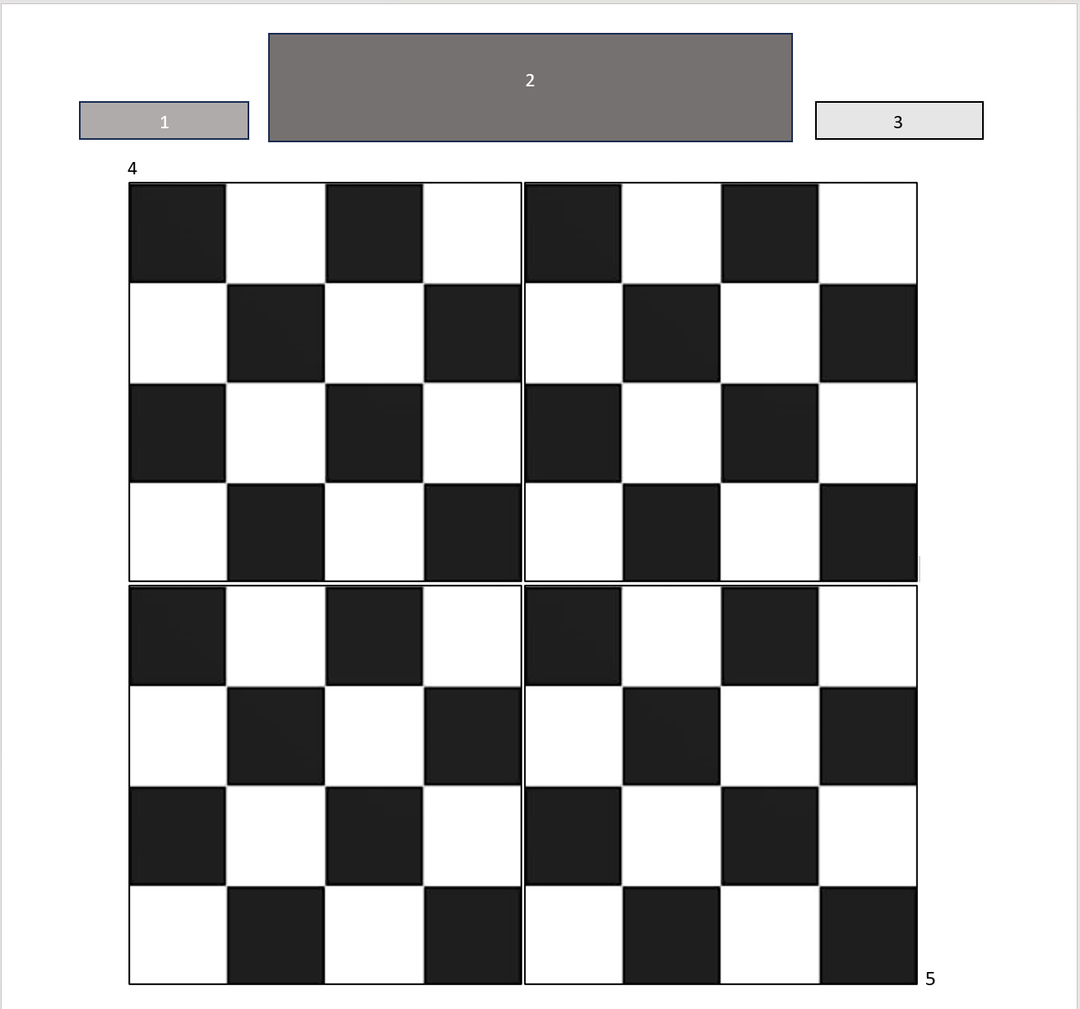

Screen 5: End Game

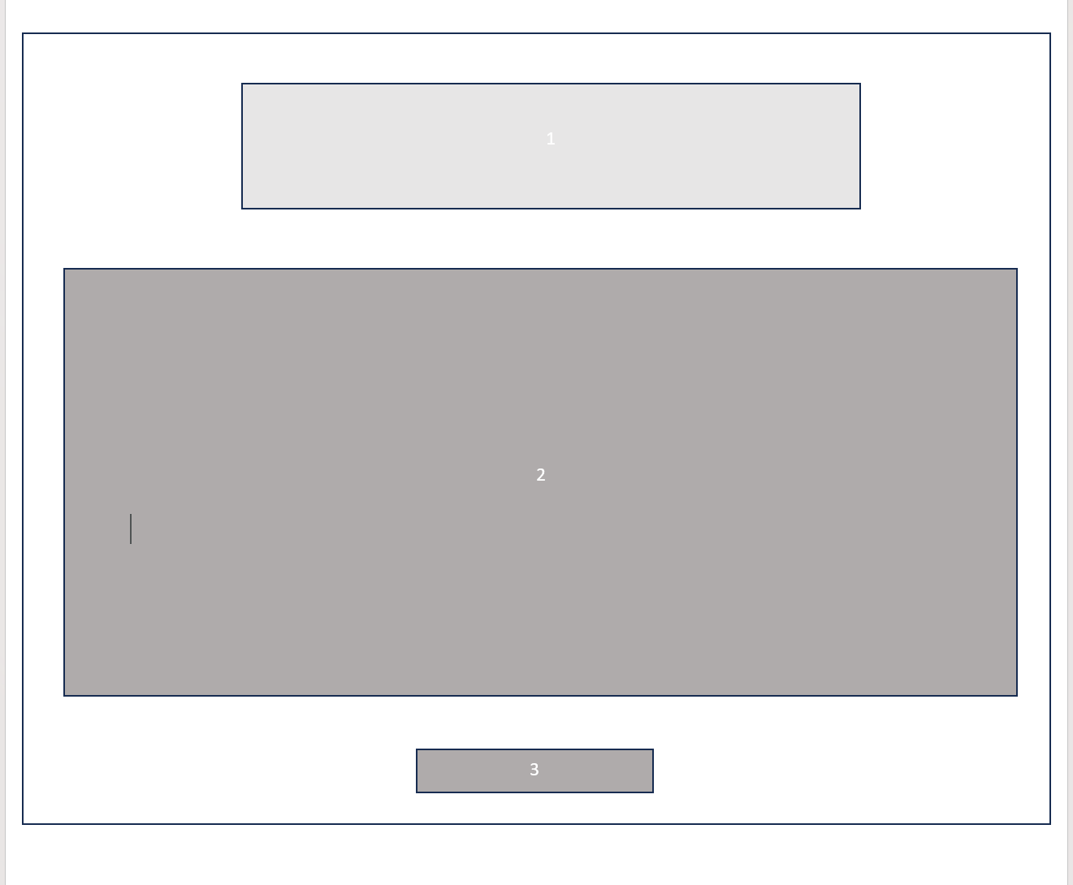

RGB values: maroon (125, 12, 54) gold (252,224,61)